  Board Members
  Officers
  Chairman of the Board
  Dr. Jerrold Chadwick, Jr.
  Vice Chairwoman
  Lindley Bucci
  Terry McGowan - Secretary
  Daniel Kenney – Treasurer
  Paul Schwab – Legal Counsel
  Tasha Museles - President
  Board Members
  Taylor Blades
  Bobby Cardoni
  John Carver III
  Christopher Chadwick
  Matt Cimino
  Steve Coomes
  Karen Fernandez
  Michael Golder
  Charmel McMillan
  Michael O’Halloran
  William Yull
  Scientific Advisory Board
  Jason Fixler, M.D.
  Young Kwok, M.D.
  Rachel Peterson, Ph.D., NCSP.
  Christine Pratilas, M.D.
  Brian Rood, M.D.
  Jeffrey Toretsky, M.D. – Chair
  Aykut Uren, M.D.
  Brigitte Widemann, M.D.
  CCF is a 501c3
  All donations are tax deductible.
  Our federal tax ID number is 52-1319756.
  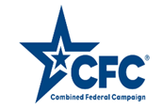
  2023 Partnerships
  CCF partners with many local organizations to raise critical funds for the treatment
  and cure of pediatric cancer.
  These partnerships include both financial contributions as well as in-kind donations.
  We are proud to keep the dollars local.
  We proudly celebrate all of our supporters, including:
  Ameriprise Financial
  Anne Arundel County Fire Department
  Bowie Baysox
  Constellation Energy
  Dole Fresh Vegetables
  EagleBank Foundation
  Friends of the Industry
  Giant Food
  Guest Services
  The Hershey Company
  Jean Kettell Studio of Dance
  The Kahlert Foundation
  MSC Mediterranean Shipping Company Inc.
  M & T Bank
  McCormick & Company
  N.E.C.A., Maryland Chapter
  PepsiCo
  Safeway Inc.
  Saval Foodservice
  Simco Logistics: Jack and Jill Ice Cream
  Weis Markets
  How your Support Makes a Difference
  Corporate, individual and foundation support makes a difference, at any level, for a child facing a diagnosis of cancer.
  The Children’s Cancer Foundation, Inc.
  5570 Sterrett Place, Suite 204
  Columbia, MD 21044
  The Children’s Cancer Foundation, Inc.
  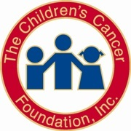
    - Dedicated to the treatment and
    - cure of childhood cancer.
  Contact US
  The Children’s Cancer Foundation, Inc.
  5570 Sterrett Place, Suite 204
  Columbia, MD 21044
  443-546-4479
  info@childrenscancerfoundation.org
  Visit us on the Web:
  www.childrenscancerfoundation.org
  5570 Sterrett Place, Suite 204 Columbia, MD 21044
  info@childrenscancerfoundation.org
  www.childrenscancerfoundation.org
 |  |  |  |  |  |  |  |  |  |  |  | 2023 Research Awardees  Johns Hopkins Hospital  -Charles Eberhart, M.D., Ph.D.  -Yiouli Ktena, M.D.  2023 CCF Giant Food NextGen Award  -Nicolas Llosa, M.D.  -Patience Odeniyide, M.D., Ph.D.  Children’s National Hospital  -Chase McCann, Ph.D.  National Cancer Institute  -Anandani Nellan, M.D.  -Haneen Shalabi, D.O.  Georgetown Lombardi Cancer Center  -Chris Albanese, Ph.D.  -Gary Kupfer, M.D.  -Aykut Uren, M.D.  University of Maryland School of Medicine  -Curt I. Civin, M.D.  2023 Non-research Programs  - The Children’s Inn  - Claire Marie Foundation  - Horizon Day Camp  - Kennedy Krieger Institute  - Nigel’s Neighborhood LLC
  Cade – Manchester, MD
  2018 CCF Ambassador to Giant Food
  In 2016, at 21 months, Cade underwent a 9- hour surgery to remove a baseball size brain tumor confirmed as meduloblastoma.
  Today, despite some complications Cade is attending school and playing soccer.
  He is “all boy”, loves sports, superheroes and Mickey Mouse.
  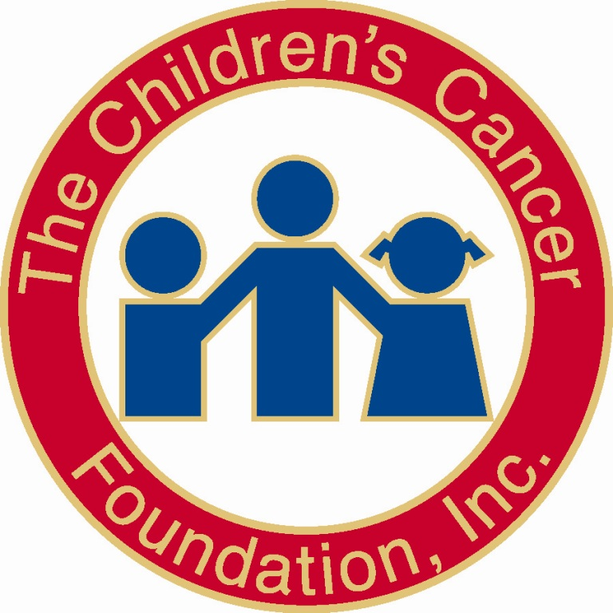
  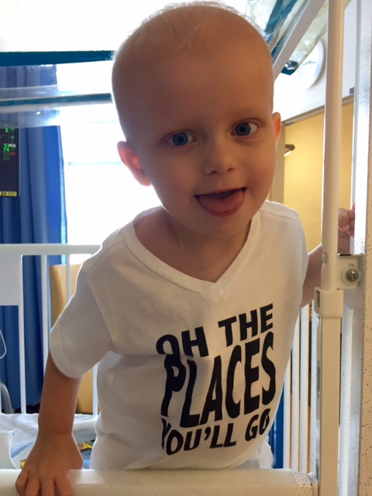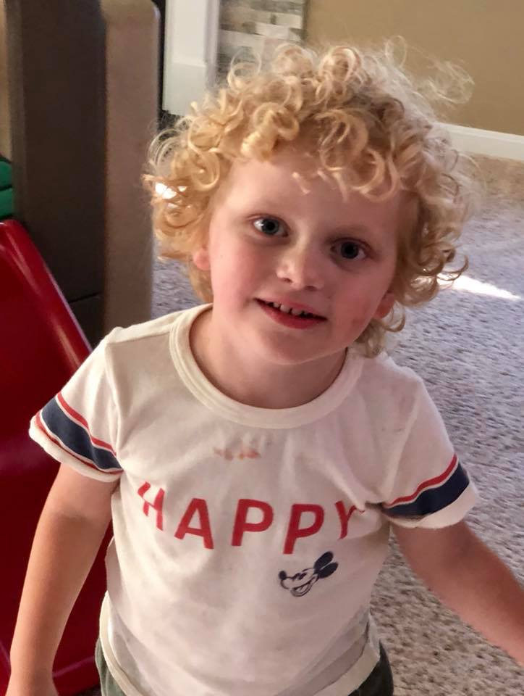
  Cancer continues to be the #1 cause of disease
  related death for children.
  - Approximately 1 in 285 children will be diagnosed with cancer before the age of 20.
  - Research for children with cancer, especially for those with sarcomas and brain cancer, lags nearly two decades behind their adult counterparts
  - Each day 35 children in the United States are newly diagnosed with cancer
  - Federal funding is lagging for pediatric oncology
  Why Support CCF
  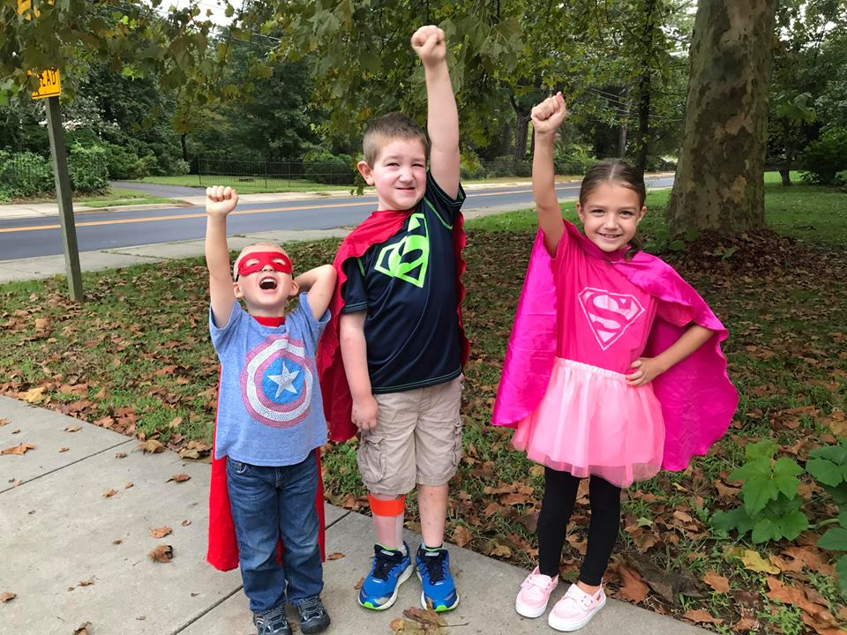
  Darren – Churchill, MD
  In 2009, at just 8 weeks old, Darren was diagnosed with a brain tumor. In 2021, Darren is 12 and is a walking, talking miracle. He has endured 3+ years of chemotherapy, 15 surgeries, over 50 MRI’s and more procedures and pokes to count. He enjoys singing, dancing, and above all, he loves to make people SMILE!
  • Today, with CCF funding critical research, new therapies have helped to keep Ava alive.
  • Today, Ava is an energetic 5th grader
  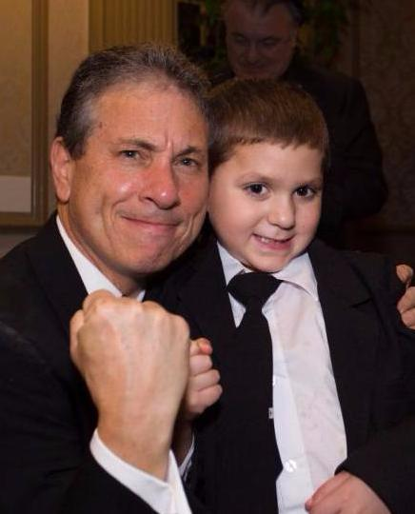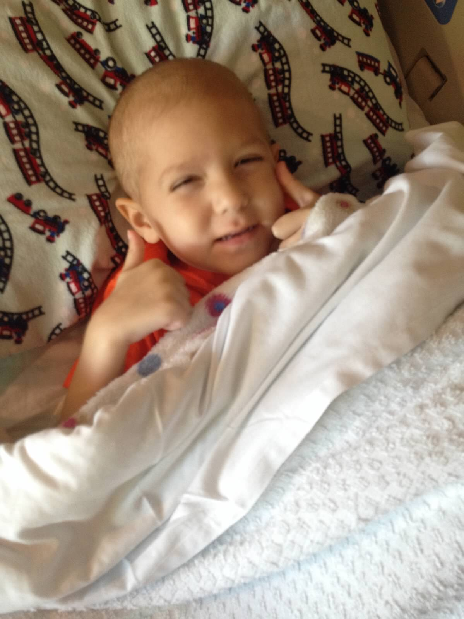
  Andrew - Silver Spring, MD
  In 2014, at the age of three, Dr. Joseph Wiley of Sinai Hospital (pictured left) diagnosed Andrew with a rare and more aggressive form of Acute Lymphocytic Leukemia (ALL). In Februrary of 2018, Andrew rang the bell ending his treatments. He loves all 9-year-old-stuff and wants to be a “baby doctor” when he grows up.

